Erick Cabrera

A20321505

ITM 312

Lab 05

**Source Code:**

/*

* File: main.cpp

* Author: Erick Cabrera

* Created on February 24, 2017, 10:16 PM

*/

#include <cstdlib>

#include <iostream>

#include <string>

#include <iomanip>

using namespace std;

// set max and min test scores

const int MAX_SCORE = 100;

const int MIN_SCORE = 0;

// declare and set array size

const int testScores = 10;

double scores[testScores];

//global variables

double low = 110;

double high = -110;

// pass by reference

double searchHigh(float (&array)[10]);

double searchLow(float (&array)[10]);

double mean(float&, float&, float (&array)[10]);

// user enters test scores

double getScore(){

double score = 100.00;

cout << "Enter a test score: ";

cin >> score;

// validate score

while (score < MIN_SCORE || score > MAX_SCORE){

cout << "Please enter a score between 0 and 100. " << endl;

cout << "Enter another score: ";

cin >> score;

}

return score;

}

// function to search for highest score

double searchHigh(double scores[], int testScores)

{

//find highest value in array

for (int inputs = 0; inputs < testScores - 1; inputs++){

if (scores[inputs] >= high)

high = scores[inputs];

}

cout << "Highest test score entered is: " << high << "." << endl;

return high;

}

// function to search for lowest score

double searchLow(double scores[], int testScores){

for (int inputs = 0; inputs <= testScores - 1; inputs++){

if (scores[inputs] < low)

low = scores[inputs];

}

cout << "Lowest test score entered is: " << low << "." << endl;

return low;

}

// function to calculate mean

double mean(double lowest, double highest, double scores[], int testScores){

double average;

double sum;

for(int inputs = 0; inputs < testScores; inputs++)

sum += scores[inputs];

sum = sum - high - low;

average = sum/(testScores - 2);

// set to 2 decimal places

std :: cout << std :: fixed;

std :: cout << std :: setprecision(2);

cout << "The average of the test scores, excluding the highest and lowest scores, is: "<< average << "." << endl;

return average;

}

int main(int argc, char** argv) {

// only allow 10 scores

cout << "Please enter 10 test scores." << endl;

int numScores = 10;

for (int inputs = 0; inputs <= testScores - 1; inputs++, numScores--){

scores[inputs] = getScore();

if (inputs == 0 || inputs < 9){

cout << "Test Score: " << inputs + 1 << endl;

}

else{

cout << "Test Score: " << inputs + 1 << endl;

cout << "" << endl;

}

}

// call functions

searchHigh(scores, testScores);

searchLow(scores, testScores);

mean(low, high, scores, testScores);

return 0;

}

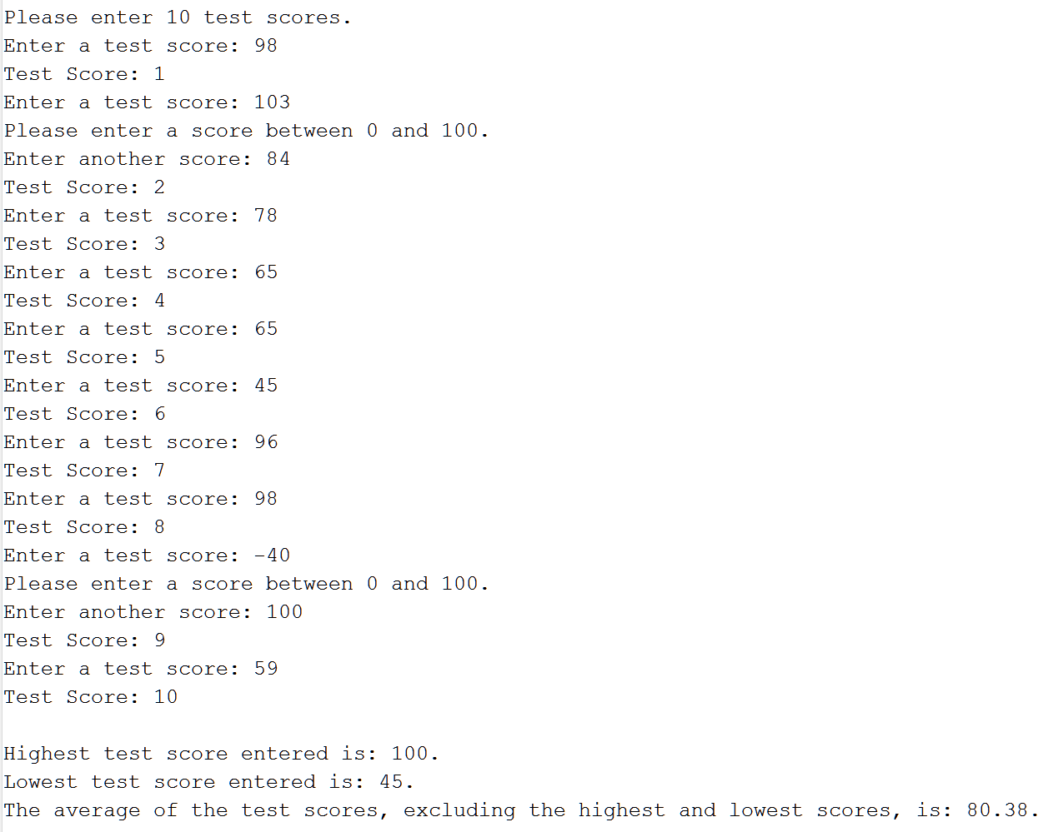**Output:**